CHAPTER 6
ECONOMIC DEVELOPMENT

EMPLOYMENT

The 1990 U.S. Census reports 74%, (218), of Lewisville’s residents over the age of 16 were employed as civilian employees. Seventy-five, or 26%, of the population over 16 years, were not in the work force. The unemployment rate for Lewisville was nine-tenths of one percent, (0.9%).

There were 36 people 16 to 19 years old in Lewisville. The census reports five had not graduated from high school and were not enrolled in school. Five, presumably the five not enrolled in school, were employed or were in the military. None were reported as unemployed or not in the labor force.

Page 6-1

GENDER

Men older than 16 years old comprised the largest group of employees. Of 153 men eligible to work, 121, (79%), were employed. Thirty-two men, (31%), were not in the labor force. There was a 0% unemployment rate in this group.

There were 140 women in the city older than 16 years old. Ninety-seven women were
employed, a rate of 69%. Two women, (2.1%), were unemployed. Forty-three women,
(31%), were not in the work force.

Page 6-2

TRANSPORTATION TO WORK

A total of 216 workers 16 years and older were surveyed about their method of commuting to work. Most of the workers in Lewisville traveled an average of 20.8 minutes to work. Most workers, 64.4%, used private transportation to travel to their employment. About 14% of the population worked at home, or was employed within walking distance of home. About 11% reported using public transportation. Since there was no public transit system in Lewisville and the surrounding area, it is assumed these workers were employed by Idaho National Engineering and Environmental Laboratory, (INEEL), and traveled to the job site on INEEL busses. About 10% of the labor force traveled to work in a car pool.

Workers 16 Years and Older 216
Percent Driving Alone 64.4%
Percent in Car Pools 9.7%
Percent Using Public Transportation 11.1%
Percent Walking or Working at Home 13.9%
Average Travel Time to Work 20.8 Minutes

Page 6-3

OCCUPATION

Although the census reported 218 people over the age of 16 employed, 216 people were reported employed under the occupational heading. There were 183 people working for private businesses; 16 for local, state, or federal government; and 17 were self-employed.

Total Employed 216
Private Business 183
Government 16
Self-employed 17

Twenty-nine people reported employment in professional specialty occupations, about 13%. Twenty-seven people, or about 12%, were employed in administrative support occupations, including secretarial and clerical work. Twenty-five people, 11%, were handlers, equipment cleaners, helpers or laborers. Eleven people, or 5% of the labor force, were engaged in farming, forestry or fishing occupations.

Page 6-4

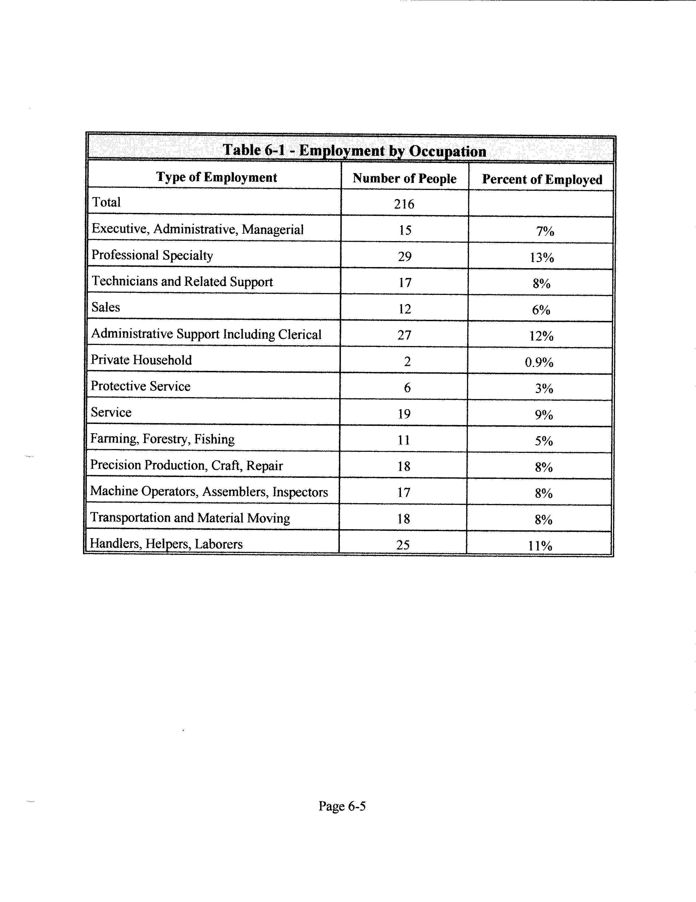

Page 6-5

INDUSTRY
The census tabulated totals for industries in which Lewisville workers were employed. Forty-one people reported working for professional and related services other than those specifically noted on the census questionnaire. Twenty-eight people reported working in the transportation industry; 25 in manufacturing; 29 in wholesale and retail trade; and 16 in construction. Although the census reported only 11 people engaged in agricultural occupations, 21 people reported working in that industry. Fifteen people within the city limits reported working in educational services.
Table 6-2 - Employment by Industry
Type of Industry | Number of People | Percent of  Employed
Total | 216
Agriculture, Forestry, Fisheries | 21 | 10%
Mining, Manufacturing Durable Goods,  Communications, Other Public Utilities | 0 | 0%
Construction | 16 | 7%
Manufacturing, Nondurable Goods | 25 | 12%
Transportation | 28 | 13%
Wholesale Trade | 12 | 6%
Retail Trade | 18 | 8%
Finance, Insurance, Real Estate | 5 | 2%
Business and Repair Services | 10 | 5%
Personal Services | 5 | 2%
Entertainment and Recreation Services | 3 | 1%
Health Services | 5 | 2%
Educational Services | 15 | 7%
Public Administration | 12 | 6%
Other Professional and Related Services | 41 | 19%

Page 6-6

HOUSEHOLD INCOME

The median household income in Lewisville for 1989 was $29,250. Forty-three of the 138 households surveyed reported an annual income of $25,000 to $34,999; 37 households an annual income of $15,000 to $24,999; and 37 reported incomes of $35,000 to $49,999. Thirteen households reported incomes of $5,000 to $14,999. Eight householders reported incomes of $50,000 to $75,000. None were below $5,000.

Page 6-7

FAMILY INCOME

The median family income was slightly higher than the median household income at $30,972. Forty-three families reported annual incomes of $25,000 to $34,999; 37 of $35,000 to $49,999; and, 31 of $15,000 to $24,999. Six families reported incomes less than $15,000; and, eight families had annual incomes of more than $50,000. None reported incomes less than $10,000 or more than $75,000.

Page 6-8

NONFAMILY INCOME

The median nonfamily income was $11,250. Six of the 13 nonfamily householders reported annual incomes of $5,000 to $9,999; one of $10,000 to $14,999; and, six of $15,000 to $24,999. None reported incomes less than $5,000 or more than $25,000.

Page 6-9

PER CAPITA INCOME

Lewisville ranks higher than Roberts, the closest neighbor in size and population, in median income levels. The 1989 per capita income in Roberts was $6,004. Lewisville per capita income for the same year was $8,561. However, Lewisville’s income levels are slightly lower than the per capita average for Jefferson County which was $9,005.

Page 6-10

INCOME TYPE

The census interviewed 138 householders to determine income source. Of those, 120 householders reported income source as wages or salaries. The average income of those householders was $27,655 a year. Twenty-two householders reported nonfarm self-employment as the source of income. The average yearly income in those homes was $9,838. Seven householders reported farm self-employment as their source of income, with an annual income of $5,671. Social Security was the second largest source of income. Thirty-seven householders were receiving Social Security, with annual incomes of $9,941. Eleven householders were receiving public assistance, with an annual income of $2,923. Twenty-five householders were receiving retirement benefits with an average of $4,233 income per year.

Page 6-11

POVERTY STATUS

The census reported 38 people, or 8%, of the population living below the poverty level. The largest group, comprising 22% of the indigent persons reported, was unrelated persons living with families. About five percent of all the families in Lewisville had incomes below the poverty level. Seven percent of those family members were children less than 18 years old, and 17.6% were children younger than five years old. No one more than 65 years old was reported living below the poverty level. No families with female householders were reported living below the poverty level.

Percentage of all Persons Below the Poverty Level 8%
Persons 18 Years and Over 5.2%
Persons 65 Years and Over 0%
Children Under 18 Years 11.7%
Children 5-17 Years 10.7%
Children Under 5 Years 14.9%
Unrelated Persons Living with Families 22.2%
All Families 4.8%
Female Householder Families 0%

Page 6-12

COMMERCE

HISTORY

Homes and farms had barely been established before William Walker built a general store in 1884. Only a few years passed before the solitary store had become part of a thriving business district. Within 30 years after the settlement of the community, at least two dry goods stores were in operation, as well as a millinery shop, a lumber store, a movie theater, a potato warehouse, a few saloons and pool halls, a few blacksmith shops, a tailor, shoe repair, and two brickyards. In 1923 the Lewisville Cheese Factory, and later, the Canner’s Seed Corporation, (Nunhem Seed Corporation), provided employment for local residents. Ray Thueson opened a restaurant in 1944, than sold it and opened another one on East Main Street, providing two cafes; and, the East Side Lumber Company sold their store to Harold Havens who built a gas station, currently Rounds Service. A hotel and confectioner’s stores joined local businesses in the early 1930's and 1940's. However, by the 1960's and 1970's most of the businesses had closed or relocated.

Page 6-13

Table 6-3 -- Lewisville Businesses, 1884 to 1946
Name of Business | Location | Year
William Walker General Store |  | 1884
Kinghorn Brickyard |  | 1888
E.A. Hawley General Store | Former Walker Store | 1892
Charles Shurtliff General Store | Log cabin later used as school | 1896
Harry A. Bramwell General Store | West Main Street, also Post Office
Saloon and Pool Hall | Former Bramwell Store
Myler General Store | East Main Street | Pre 1912
Neil Gilchrist General Store | Corner of Lincoln and Main Streets | 1898
Christen Sorensen Shoe Repair
Tailor Shop
ZCMI, Saloon, Pool Hall, Butcher | Alternately occupied Gilchrist Store
Confectionery Store, Candy Store | Main Street | After 1902
Harvey Maynard Blacksmith Shop | West Main | 1906
Mrs. Ray Jardine Millinery |  | 1907
Thomas A. Hoggan Store | North across from Gilchrist Store | 1909
Erickson Potato Warehouse | East Main (now Clement’s) | 1913
Curtis Ellsworth Blacksmith Shop | West Main Street | 1917
Frederick Frederiksen Theater | Former Bramwell Store on West Main | 1917
East Side Lumber | 103 East Main | 1918
Haven’s Service (now Round’s) | 103 East Main | 1920
Lewisville Cheese Factory | East of City | 1923
Canner’s Seed Corporation (later Nunhem’s) | East Main Street | 1930
Charles Aiman Seed Warehouse | Jefferson and Main Streets | 1935
E.R. Beedle Blacksmith Shop | Block west of Gilchrist Store | 1930's
Reuben Casper Blacksmith Shop |  | 1940's
Ball Brother’s Potato Warehouse | North of town | 1942
Ray Thueson Cafe (Former Dutson Store) | West Main | 1944
Ray Thueson Cafe | East Main east of City Offices | 1946

Page 6-14
BUSINESS DISTRICT

Currently, (1998), only a few businesses remain on Main Street, although several home-based businesses exist throughout the city. A 1998 telephone directory listing shows ten business addresses within the city limits. Nine other businesses are located outside the city limits. Kozy Kabin Log Furniture occupies the extensively remodeled building of the Gilchrist General Store and is used as a carpentry shop. Lewisville Produce, Clement Brothers, and Idahoan Foods are listed separately in the telephone book, but are part of the same corporation. They are engaged in a potato processing business at the site where Erickson Potato Warehouse and Nunhem Seed Corporation were located. Casper Construction is a home-based business on East Main Street. Rounds Service occupies the same Main Street location where it was established in 1923. Other people living in Lewisville have businesses in Idaho Falls, Rigby, Rexburg, Menan, or other cities. The city offices and library, community center, and Jefferson Central Fire District Station are the only other remnants of the former Lewisville business district.

Page 6-15

Table 6-4 -- 1998 Lewisville Businesses
Name of Business | Street Number or P.O. Box | City and Zip Code
AC Morris and Sons | P. O. Box 43 | Lewisville, Idaho 83431
Aspen Fine Cabinetry | 401 North 3400 East | Lewisville, Idaho 83431
*B & K Sales | P. O. Box 32 | Lewisville, Idaho 83431
Ball Brothers Produce | 508 North 3470 East | Lewisville, Idaho 83431
*Candyland Daycare | P. O. Box 107 | Lewisville, Idaho 83431
*Casper Construction | P. O. Box 225 | Lewisville, Idaho 83431
*Clement Brothers | 209 East Main | Lewisville, Idaho 83431
Dave’s Electric | 421 North 3500 East | Lewisville, Idaho 83431
*GKS Transportation | P. O. Box 124 | Lewisville, Idaho 83431
Gregory Sievers | 3594 East 500 North | Lewisville, Idaho 83431
Hayes Construction | 447 North 3400 East | Lewisville, Idaho 83431
*Idahoan Foods | P. O. Box 130 | Lewisville, Idaho 83431
*Idahoan Transportation | P. O. Box 39 | Lewisville, Idaho 83431
*Kozy Kabin Log Furniture | 205 South Jefferson | Lewisville, Idaho 83431
*Lewisville Produce | 209 East Main | Lewisville, Idaho 83431
Skaar Louis & Sons Feedlot | 421 North 3200 East | Lewisville, Idaho 83431
Pete Mickelson & Sons Masonry | 573 North 3600 East | Lewisville, Idaho 83431
*Rounds Service | 103 East Main | Lewisville, Idaho 83431
Walkers Feedlot | 400 North, Lewisville Hwy. | Lewisville, Idaho 83431

*These businesses are located within Lewisville City. The other businesses have Lewisville postal addresses, but are located outside the city boundaries.

Page 6-16

BUSINESS LICENSING AND ORDINANCES

Although the city has an ordinance requiring business licenses, none have been issued for the past several years, and no record is available for licenses issued since the ordinance was revised in 1923. Ordinance 7, established by the city council in 1904 and amended in 1923, defined five classes of businesses for which different fees were charged. The town marshall was assigned the responsibility of collecting license fees. In 1906, the city council established Ordinance 17 prohibiting gambling and the admission of anyone less than 16 years old to saloons and billiard halls. Ordinance 19, established in 1907, requires a $300 annual liquor license for businesses selling alcoholic beverages consumed on the business premises, and $100 annual fee for beverages sold to be consumed off the business premises. There is no record of repeal for any of these ordinances, and they are presumably still in effect.

Currently, (1998), Menan and Lewisville are the only local small cities requiring business licenses. Although Rigby does not require a license, businesses must abide by zoning codes. Roberts and Ririe, the two cities closest in size and population to Lewisville, do not require business licenses. Menan requires an annual license of $25 for all businesses.

In addition to requiring business and liquor licenses, the city also has ordinances regarding disposal of waste, the upkeep of property, public nuisance, and safety issues that apply to businesses as well as private residences.

Sources: 1990 U.S. Census
Lewisville Centennial Book (available at the City Library)
1998/1999 US West DEX Telephone Directory
Lewisville City Ordinances

Page 6-17

